TECHGENE PROPOSAL

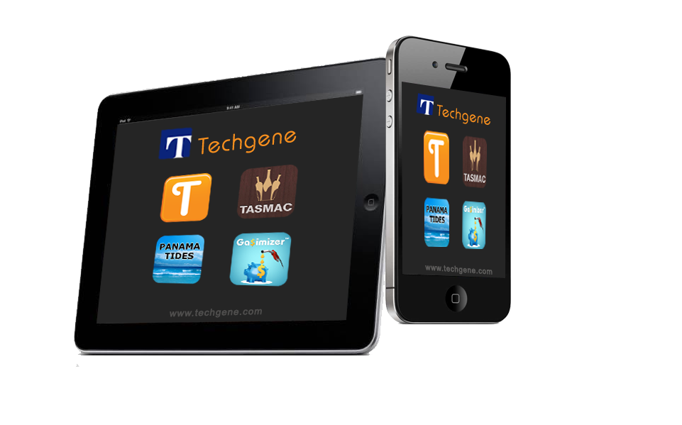

Techgene Solutions Proposal

App Publisher: Scot Robinson

The App Company

**PREPARED BY**

**John Talluri**

Techgene Solutions

john@techgene.com

Phone: 040-40163101

**PRESENTED ON**

12th July, 2012

**DESCRIPTION ACCORDING TO THE APP COMPANY (PUBLISHER)**

DESCRIPTION

Recently, we at The APP Company partnered with trade exchange business (“The Client”) to help them create a mobile iPhone app for their members. The app is intended for their members only, and will feature Groupon-esque deals centered around a business-to-business barter economy, based largely in Arizona and parts of California and Texas.

Reference App: <http://itunes.apple.com/us/app/citygro/id466334190?mt=8>

**The Client Background**

The Client is essentially a membership network of wide-ranging businesses and vendors. Within the community, members can exchange goods and services in a non-cash barter economy. These members range from restaurants and healthcare to international travel. The Client envisions this app as a highly functional support tool that will allow members to search for other member businesses and deals/offers. Necessarily, their vision of this app will center around highly-specialized search functions (detailed below).

To clarify, the Client already hosts a member website that is administrated in-house. Therefore there will be no need to design a consumer website and this partnership is purely intended to build an iPhone app to supplement their website. Since this app is intended for members, there will be a member log-in required, but it will not ask users to register, it will just require validation to be routed through the administrative website. *The Client is currently working with their website provider to provide us with an API whereby we can send a username/password to an online script and the script will verify whether or not the credentials are valid*

With that in mind, below is a full list of features that we expect the app to contain.

**Features**

* Member log-in
* Membership username/password verified through host website, no registration required. NOTE: if the client is not able to get the website provider to provide an API to the login, we will create a user table in the CMS we build, import existing user info, and provide appropriate functionality to maintain user info and verify user credentials through app.
* Categorical search, including ability to search “All Categories”
* Filter
* Ability to filter all search results by geography (e.g. pre-selected filter relegated to Phoenix area only, etc.). Setting to allow user to specify their geographic region. Most member records in the system will be associated with a geographic region. The four likely regions to start out will be Phoenix AZ, Tucson AZ, Texas and California. So users can set their region and will only see matching search results in their region. However, some businesses, such as hotels might not be associates with a region.
* Search sortable alphabetically or closest to the user’s location, an address or distance from another vendor which has previously been selected.
* Search results viewable in list or map view
* Adjustable search settings
* Map view with pins that populate according to search criteria
* GPS ‘near me’ function to find vendors near the user’s location.
* Ability to map vendors around manually-entered address (not necessarily where you are at the time).
* “Featured Vendors” section- back-end admins manually select deals that populate under “Featured Vendors” designation. When the admin is creating/modifying each vendor record, there will be a ‘featured’ checkbox. These deals will appear under the Featured Deals tab.
* Detailed information about businesses (accessible by clicking both listing or map pin), including the ability to dial, email, or access website.

**We have reviewed the following along with the associated wireframes, as provided on July 12, 2012 and agree that everything in the description and wireframes will be included in the App.**

**Detailed Wireframe- Our Vision for the App**

Here we will walk through our wireframe (see PDF “VCA Engineering Storyboard” for reference – located in dropbox) in detail and give an in-depth picture of how we want the app to function. Each number next to heading below, corresponds to the screen featured on the storyboard and a file name with that same screen in higher resolution. The screens are a creative guide and contain exactly what we want.

**(1) Splash screen-** displaying VCA logo, “powered by The APP Company” subtly included in frame

**(2) Login Screen-** This screen will prominently display the member login requesting username and password, which will be routed through the host website for verification. There will be the option to send VCA an email, which will launch the mail app. Also on this page, we want two buttons, one which will say “VCA Program Info” and the other which will link to the VCA website.

**(2)(a) VCA Program Info-** This screen will list 7 things as shown on the screen mockup. Each will link to its corresponding page that is the same as below listed in the ABOUT US (3)(b)(2), (3)(c)(1), (3)(c)(2), (3)(c)(3), (3)(c)(4), (3)(c)(6) and FAQ sections (3)(b)(1), (3)(b)(2) noted in further detail below (excepting that there will be no “home” button on upper right to return to screen (3)). One additional item here is the (2)(a)(1) “About VCA.”

**(2)(b) VCA Website-** This is the screen that links to the VCA website. It will allow users to browse the website within the app, but also include the option of navigating out of the app via the arrow in the bottom right corner.

**(3) Home Page** - After members login, they will land on this page. It will include a Filter button, see (5) Filter below, and search bar along the top (from this screen, it searches VCA member list all categories), with the majority of the screen featuring a list of categories, with the first being the option to select “All Categories.” Along the bottom we want three buttons: Featured, FAQ, and About Us. The list of categories comes from the database.

**(3)(a) Featured Members**- This page lists featured members. That list comes from the database manually entered via back-end administrators, and will populate in a list sorted by category. These should be displayed by category with category headers at beginning of each category. Just as in the case of path one of screen (4) below, users select members to get (4)(a)(1) VCA Member screen and can map to get screen (4)(a)(2) Map It screen.

**(3)(b) FAQ-** This page lists the options to select for FAQ.

**(3)(b)(1) FAQ Using the App**- this will be a text-based page.

**(3)(b)(2) FAQ Using VCA** - text-based page.

**(3)(c) About Us -** This page will include links to the 6 pages.

**(3)(c)(1)** VCA Contact Info- text-based

**(3)(c)(2)** VCA Facebook- mobile Facebook page within app

**(3)(c)(3)** VCA Twitter- mobile Twitter feed within app @VCAbarter

**(3)(c)(4)** VCA Blog- mobile blog within app

**(3)(c)(5)** Member info- This screen will tell you who you’re logged in as, and provide the option to logout.

**(3)(c)(6)** About The App Company- text-based

**(4) Search Results -** If you select a category from (3) Home Page, this is the screen that will appear. It will populate a list based on what category you selected and any filters selected in (5) Filter. If all categories or a single category is selected, category names appear as headers before the list of members for that category appears as shown in mockup screens.

From this screen, the search bar at the top searches VCA member list from the search results/category(s) selected.

Each member will have its name, address and distance from the user shown. If location services is not turned on, distance from user does not display. If member does not have an address, then “No Address” is displayed and these results are at end of the list.

This screen will have the option to: (a) view the entire list that is on this page (search results) in a map view (by pushing the “Map It” button); or (b) select one of the businesses from the list (by pushing the arrow to the right of the member name).

***Path one:*** If you select an individual business from the (4) Search Results.

**(4)(a)(1) VCA Member –** This screen show the information about the business selected. Within this screen, the email address will launch email function, the web site will launch web site framed within app, like screen (2)(b). Selecting the phone number will launch the phone application and dial the number. Info field will scroll and can contain a lot of information. If there is no icon/image, nothing will appear in that spot on screen. If there is no address for this member, then the “Map It” button does not appear or is grayed out. You can also select “Map It,” which will launch screen (4)(a)(2) and map only the location selected.  
 **(4)(a)(2) Map It –** Selecting the “Map It” button, from (4)(a)(1) VCA Member, will map that one location only. The map will function like any regular mapping function does with zoom, a button to center user location on the screen and a search for addresses, etc. This screen will have a GPS locator to indicate where you are (you can click the triangle button on the bottom left to locate yourself on the map). Along the bottom of the map, there will also be the option to enter an address to search. Note: if location services is not turned on, nearby button will not be active.

***Path two:*** If you select the “Map It” button from (4) Search Results.

**(4)(b)(1) Map It** – Selecting the “Map It” button from (4) Search Results, will map the entire search results list. The map will function like any regular mapping function does with zoom, a button to center user location on the screen and a search for addresses, etc. This screen will have a GPS locator to indicate where you are (you can click the triangle button on the bottom left to locate yourself on the map). Along the bottom of the map, there will also be the option to enter an address and search for members near that stipulated address (the result of this address would still show the locations near this new address from the search results – an address that is not necessarily where you are at that moment). The results will appear with pins. When a user zooms in and selects a pin, (4)(b)(2) VCA Member Screen will appear with details of selected location.

**(4)(b)(2) VCA Member –** Within this screen, the email address will launch email function, the web site will launch web site framed within app, like screen (2)(b). Selecting the phone number will launch the phone application and dial the number. Info field will scroll and can contain a lot of information. If there is no icon/image, nothing will appear in that spot on screen. In this case, if you select “Map It,” it maps just this location.

**(5) Filter -** The Filter will give users the option to sort results by distance or member name (alphabetically), and to narrow results by region. The regional options will include Phoenix, Tucson, California, Texas or All Regions. Once the user adjusts the filter, they will hit an Apply button. When they hit apply button, they also return to previous screen. Whatever is selected in Filter is saved as default until user next changes it. Notice cancel button, which cancels any selections prior to apply button being pushed.

**Overall**

* Home button takes you to screen (3). It will not be a “home” button, but more of a “list” looking button as in screen (3)(a)
* Back always goes back to the screen you came from.

**BACK-END CMS**

You will need to create the CMS to control the data. The CMS will consist of a number of tables:

**Region**

As defined above, most vendors will be associated with regions and users will have the ability to filter by region.

**Category**

These are the main vendor categories. All vendors will be associated with one or more categories such as Restaurant, Amusement Park, Advertising, etc., etc.

**Vendor**

This will contain the main vendor information such as name, description, address, phone number, website and it will point to one or more categories and an optional region. Some vendors could be associated with no region or several regions.

NOTE: Some vendors might be associated with a Region, but do not have an address that could be mapped. An example of this would be a home builder who does not have a physical address. The vendor in the case would come up for the region in list view, but no in a map or any ‘near me’ sort. When viewing in map view or in a ‘near me’ sort we will probably need to notify the user that there are one or more vendors that match their criteria who do not have an address and there will be a way to show these vendors.

**User List**

The client will likely have their website vendor create an API so that the app can verify active user credentials. To the extent that the website vendor does not make the API available, we might need to create a user table in our CMS.

**Importing Data**

The Client has 1000’s of vendors. We will suggest a CSV format and they will give us the data for a one-time import into our tables.

**PLATFORM**

You will create the CMS using PHP via a common framework such as Code Igniter. You will also use a CSS template formatting package specified by The APP Company – most likely this theme from themeforest:

<http://themeforest.net/item/crown-premium-responsive-admin-theme/1733280?WT.ac=category_item&WT.seg_1=category_item&WT.z_author=Kopyov>

You will host the staging server during testing and give The APP Company full access and credentials for testing. You will also give The APP Company access to the code to review. You will install the final/approved code and database structure with all live data to the client’s server.

APP CODE AND PROJECT MANAGEMENT SOFTWARE

You will provide us with source code each time you send us a new build. The source code will be placed in our dropbox folder. You will also use our provisioning profile to create IPA files and load to testflight. You will invite our testers to download the testflight builds.

You will use a project management software platform designated by The APP Company for ticketing, but tracking, communicating new features, etc. Our preferred software is Trello.com.

PROTOTYPE

The second payment installment will be made upon the delivery of a working prototype. This will be defined as a working App that contains essentially all of the features outlined above. We understand that there will be testing, bug fixing, UI enhancements, etc., that still need to be made. This prototype will require a working CMS, since the App needs to talk to the CMS database

**PRICING & TIMELINES**

TOTAL PROJECT FEE USD: 5400

DEVELOPMENT TIME 2 Months

PRICING

**Payment Break-Ups**

Kick –off USD 1800

Prototype USD 1800

Delivery USD 1800

**Techgene’s Role**

Mobile Application

Backend / CMS

**PRE-PRODUCTION PHASE**

**PLANNING**

A successful project begins with proper planning and outlining of the key steps, players, elements and goals. These pieces are all assembled and identified in a digital Project Binder that includes: Project Requirements, Project Wireframe, Software Details & Sequence, a Test plan, Design Guide and the Project Plan outlining the Timeline and Milestones. This Binder is approved by the Client and used as a guide throughout the entire process.

**DESIGN**

Working from the Specifications and any direction from the Client, the Designer develops the initial user interface for the project. The designer develops the overall look and feel as represented by screen images and the key graphic elements, including icons, backgrounds, menus, etc. The Design concludes with an approval by the client of the Key Screen Artwork.

**PRODUCTION PHASE**

**PRODUCTION GRAPHICS**

The first stage of production involves the preparation of all designs and artwork for engineering. Working from the Key Screen Artwork, a production designer will develop all of the remaining screens and elements of the project, providing a set of production ready artwork .

**ENGINEERING**

All of the planning and design components come together and are implemented as the project moves through Engineering. The engineering team works toward the milestones of the project plan, delivering prototypes and test versions of the project at regular intervals. The Client and Producer work together reviewing these prototypes and providing feedback throughout the process, culminating in a final version ready for testing.

**FEEDBACK DIALOGUE**

During the Engineering phase, time is allotted for reviews by the Client and subsequent analysis by the Engineers and Producer. This time is distributed throughout the Engineering phase and represents an important part of the collaborative process between our teams.

**QUALITY ASSURANCE**

Toward the end of the Engineering stage, a Quality Assurance (QA) team begins reviewing the project against the Specifications to insure that everything is performing and looking correctly. The QA team is charged with testing and reviewing all possible use scenarios and identifying all possible areas of confusion or error within the project. A final approval from QA as well as the Client is required to complete a project.

**DEPLOYMENT**

Once completed, the project must be prepared and submitted to the appropriate store or marketplace. Our Deployment Specialist can assist the Client with this process.

**PROJECT MANAGEMENT**

Throughout the entire project, a Project Manager will act as the central point of contact for the Client - providing regular updates and insuring that the project stays on schedule. The Project Manager will coordinate all of the various departments and teams to make sure everything is available and properly documented to allow the project to proceed smoothly.

PRODUCTION

ABOUT TECHGENE

**About Techgene**

An iOS and Android applications development experts with 6 years of experience in providing quality solutions to businesses and individuals.  
  
Techgene is envisioning to be one of the best Mobile Applications developers and we know we can get there only with professionalism, technical abilities, timely deployment and cost-effectiveness, hence they became our work style.

**Service Description**

Techgene is one of India's leading software solution provider established in 2002. We are dynamic and professional people working in IT industry for last 10 years providing quality solutions to businesses and individuals seeking solutions to a wide variety of needs.

AGREEMENT

**Agreement:**

Publisher / Client:

Name: Jason Moskowitz

Company: The App Company

Sign: _________________________________

Date:

Developer:

Name: John Talluri

Company: Techgene Solutions, begumpet Hyderabad.

Sign:

Date: 12th July, 2012